Simple is Eco-Friendly but Complex is Effective: Inferences from Visual Complexity in Package Design

WEB APPENDIX A. ADDITIONAL DETAILS FOR PILOT STUDY 2
WEB APPENDIX B. ADDITIONAL DETAILS FOR STIMULI PRETEST 5
WEB APPENDIX C. ADDITIONAL DETAILS FOR STUDY 1 7
WEB APPENDIX D. CONCEPTUAL REPLICATION OF STUDY 2 8
WEB APPENDIX E. ADDITIONAL DETAILS FOR STUDIES 3A AND 3B 12
WEB APPENDIX F. CONCEPTUAL REPLICATION OF STUDIES 3A AND 3B AND PERCEPTUAL FLUENCY TEST 17
WEB APPENDIX G. ADDITIONAL DETAILS FOR STUDIES 4A AND 4B 25

The authors have provided these materials to enhance comprehension of their paper.

WEB APPENDIX A. ADDITIONAL DETAILS FOR PILOT STUDY

A pilot study was conducted to observe whether consumers consider tangible manufacturing resources (i.e., energy, raw materials, production steps, and ingredients) when considering the eco-friendliness or effectiveness of a product.

Method

Participants and design 83 Prolific workers were recruited for monetary compensation. This excludes 28 errant respondents who provided irrelevant responses.

Procedure Participants were asked, “What comes to mind when you think of how effective (eco-friendly) products are made?” and were asked to provide three open-ended responses for each condition (within-subjects). The question was worded in terms of manufacture to narrow the range of possible responses and discourage responses beyond the scope of this research. The order of effectiveness and eco-friendliness conditions was randomized.

Results

In response to the efficacy question, 67.5% of respondents mentioned some type of tangible manufacturing resource in at least one of their responses (21.7% mentioned it twice out of the three). In response to the eco-friendliness question, 91.5% of respondents listed some type of tangible manufacturing resource at least once (37.3% mentioned it twice and 32.5% mentioned it three times). See Table W1 for examples of responses. While energy was mentioned much less in the efficacy condition, all other forms of tangible resources were repeatedly brought up in both conditions alike.

Table W1
Examples of Responses
Condition | Efficacy Condition | Eco-friendliness Condition
Energy |  | “Eco-friendly products are made locally to reduce energy use associated with transportation”  “Low energy or water use”  “Eco-friendly products are made using low energy methods.”
Raw materials | “Expensive, used the best materials not cheap ones”  “From materials that are abundant”  “Effective products are made with the best materials” | “Eco-friendly products are made with raw materials that don't harm the natural world”  “Sourcing of appropriate materials”  “Sourcing raw goods ethically”
Production steps | “Effective products are produced using state of the art manufacturing techniques”  “The processes by which they are made”  “There are rigorous QC/QA processes implemented after the product is produced but before it is shipped to the customer” | “Eco-friendly products are made using methods that are best for the planet, even if they aren't "optimal" from a manufacturing approach”  “The process is environmentally friendly - low emissions and waste”  “Efficient manufacturing”
Ingredients | “They use a lot of resources”  “The use good ingredients”  “Quality components” | “Making their products with less water usage”  “They use minimal resources”  “Reduced resource consumption”

It is important to note that participants' open-ended responses revealed a variety of inferences beyond our focal construct of tangible manufacturing resources. As evident in Table W1, responses encompassed not only considerations about the amount of tangible resources (e.g., "a lot of raw materials," "many production steps") but also resource quality dimensions (e.g., "expensive, used the best materials," "quality components") and other manufacturing-related inferences. This diversity of responses is entirely expected and consistent with prior research demonstrating that consumers draw multiple, simultaneous inferences from visual and conceptual cues (Kardes et al. 2004).
The primary objective of this pilot study was to establish that inferences about the amount of tangible manufacturing resources arise spontaneously and frequently when consumers consider how effective and eco-friendly products are manufactured—not to suggest that such inferences are the exclusive or only possible pathway. Indeed, claiming that perceptions of tangible manufacturing resources are the sole inference would be implausible given the rich associative networks that consumers possess. Rather, our focus throughout this research is on documenting and understanding one important and systematic inference pathway—the link between perceived amount of tangible manufacturing resources and judgments of efficacy and eco-friendliness—while acknowledging that other inference mechanisms may operate simultaneously in naturalistic consumer decision-making contexts.

WEB APPENDIX B. ADDITIONAL DETAILS FOR STIMULI PRETEST

A stimuli pretest was conducted to assess whether the product replicates used in the main studies indeed represented varying levels of complexity (vs. simplicity). We predicted that the complex package will be perceived to be more visually complex relative to the simple package and vice versa.

Method

Participants and design 600 Prolific workers were recruited for monetary compensation.

Procedure Participants were randomly assigned to either a visually complex or simple condition and were shown one replicate from the six set of replicates. The brand names of the energy drink, soap, protein powder, and paper towel replicates were counterbalanced. The other two replicates did not have different brand names. Participants were then asked to look at the product package and report their perceptions about its visuals on three items (1 = “simple” to 9 = “complex,” 1 = “plain” to 9 = “elaborate,” and 1 = “few visual details” to 9 = “main visual details”). The three items were combined to create a complexity index, such that higher values represented higher perceptions of visual complexity.

Results

The three items for each set of replicates showed satisfactory reliability (α_{energy} = .93; α_{soap} = .86; α_{protein powder} = .90; α_{paper power} = .84; α_{cleaner} = .95; α_{lotion} = .93). For each replicate, simple package was perceived to be simpler and complex package was perceived to be more complex. The results are summarized in the table below.

Table W2
Stimuli Pretest Results Summary
Replicate | M_{complex} | SD_{complex} | M_{simple} | SD_{simple} | F-value | p-value
Energy Drink | 5.77 | 1.75 | 2.65 | 1.66 | 82.19 | <.001
Soap | 3.14 | 1.43 | 1.80 | 1.18 | 26.08 | <.001
Protein Powder | 4.02 | 1.70 | 2.07 | 1.31 | 38.21 | <.001
Paper Towel | 3.27 | 1.35 | 1.70 | 0.68 | 51.88 | <.001
Cleaner | 6.23 | 1.60 | 1.83 | 0.95 | 283.91 | <.001
Lotion | 7.11 | 1.56 | 3.08 | 1.48 | 177.84 | <.001

WEB APPENDIX C. ADDITIONAL DETAILS FOR STUDY 1

Measures

Relative focus on eco-friendliness vs. efficacy (3 items) When people make purchases, they usually choose based on what they consider to be important. Please indicate what you consider to be the most important benefits when you are purchasing soaps in general from the options below:
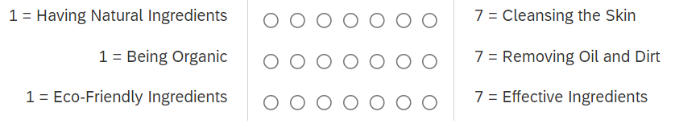

WEB APPENDIX D. CONCEPTUAL REPLICATION OF STUDY 2

This study (preregistration: https://aspredicted.org/SFM_XRL) provides a conceptual replication of Study 2. We tested whether the salience of an efficacy (vs. eco-friendliness) evaluation criterion increases the preference for product options with a visually complex (vs. simple) package design. We hypothesized that consumers perceive visual complexity (vs. simplicity) as requiring more (vs. less) resources to produce, which in turn leads them to infer product efficacy (vs. eco-friendliness). We designed simple and complex versions of products in four categories (soap, energy drink, protein powder, paper towels). If our hypothesis is correct, consumers should be more likely to choose a visually complex (vs. simple) option when they have an efficacy (vs. eco-friendliness) evaluation criterion.

Method

Participants and design We recruited 395 U.S. Prolific participants (64.6% female, M_{age} = 33.04) in exchange for a small monetary compensation. We used an attention check procedure where participants were asked to select their ‘Background and Employment’ from a dropdown list. Participants were instructed as follows: ‘During this survey you will answer questions using your judgment. Background experiences and employment can be an important factor for these types of tasks. Please select your occupation from the menu below. In order to demonstrate that you have read these instructions, please select farming, fishery and forestry as your answer to the question below. Failure to do so will disqualify you from taking this survey. Please be assured that we will keep your answer confidential.’. Any participant who did not select the correct response ‘Farming, fishery and forestry’ was informed that they did not pass the attention check and were excluded from completing the study. A total of 98 participants failed the attention check. We note that attention check failure exclusions happened prior to random assignment and exposure to any of the manipulations and stimuli. In addition, we excluded five additional participants who did not complete the study. Hence, the final sample consisted of 395 participants.
This study had a 2 (evaluation criterion: efficacy vs. eco-friendliness) x 4 (product replicate: energy drink, soap, protein powders, paper towels) mixed design. Evaluation criterion was manipulated between-subjects and replicate was a within-subject factor. Each replicate was presented as a choice between a visually complex and a simple option.

Procedure Participants made four consecutive choices, each between two options in a product category (energy drinks, soaps, protein powders, paper towels). Category order was randomized. In each choice, we asked participants to consider either an eco-friendliness or efficacy evaluation criterion. This between-subjects evaluation criterion (efficacy vs. eco-friendliness) was held constant across the four choices for each participant.
For each product category, participants saw a visually complex and a visually simple option, presented in a randomized order. In the efficacy evaluation criterion condition, we asked participants, “Imagine you are shopping for [product category]. Which one do you think is more effective?”. In the eco-friendliness evaluation criterion condition, we asked, “Imagine you are shopping for [product category]. Which one do you think is more environmentally friendly?”.
Visual complex (simplicity) was operationalized via the number of distinguishable visual elements present on the product package (see appendix C for all materials). Of note, there were no informational differences between the visually complex and simple options within each category. Package graphic designs consisted of abstract geometrical patterns, to avoid implying any additional information through the design. Within each product category, we randomized the names of individual brands. We pretested all these replicates to ensure participants perceived the visually complex packages as indeed more complex (web appendix B). After making their four choices, participants provided demographics.

Results

We ran a generalized estimating equations (GEE) model, which is a generalized form of logistic regression for choices observed in a repeated measures design (Ge et al. 2012; Liang and Zeger 1986), with a 2 (evaluation criterion) × 4 (product replicate) mixed design. The analysis revealed no evaluation criterion × product replicate interaction (Wald χ²(3) = 2.19, p = .53), suggesting that the pattern of results is consistent across replicates.
A z-test that aggregated all choices of visually complex vs. simple products for each participant showed that in the efficacy maximization condition, the choice share of complex (relative to simple) products was significantly greater than 50% (71%, z = 11.74, p < .001). Conversely, in the eco-friendliness evaluation criterion condition, the choice share of simple (relative to complex) products was significantly greater than 50% (75%, z = 14.78, p < .001).
The same pattern was observed for each of the replicates individually. In the efficacy maximization evaluation criterion condition, the choice share of visually complex (relative to simple) products was greater than 50% for energy drinks (67%, z = 4.69, p < .001), soaps (70%, z = 5.68, p < .001), protein powders (69%, z = 5.26, p < .001), and paper towels (76%, z = 7.25, p < .001). Conversely, in the eco-friendliness evaluation criterion condition, the choice share of visually simple (relative to complex) products was greater than 50% for energy drinks (81%, z = 8.76, p < .001), soaps (71%, z = 5.91, p < .001), protein powders (78%, z = 7.91, p < .001), and paper towels (71%, z = 5.77, p < .001).

Discussion

This study is a conceptual replication of study 2 by providing evidence of generalizability and robustness for our effect, showing that people are more likely to choose a visually complex (vs. simple) option when considering an efficacy (vs. eco-friendliness) evaluation criterion. The effect holds across different product categories, including food and non-food consumer packaged goods. These results extend the generalizability of our findings beyond previous research that has focused on food (Ton et al. 2023).

WEB APPENDIX E. ADDITIONAL DETAILS FOR STUDIES 3A AND 3B

Stimuli generation prompt

Please create two images, with a store shelf with 9 different soap boxes. The proportion of each of the boxes should be 3x4, horizontally long. All boxes should be 4 width x 3 height. Please make the images bright, like they were shot under bright or natural lighting.
Please create two versions:
1. Version 1: Visually complex boxes
- All soap boxes should have visually complex design. Do not include any informative elements (e.g. mountain, waterfall) or symbolic design (e.g. leaves, bubbles). They should be purely graphic without any meaning. The designs should be visually cluttered without adding any information or meaning.
- There should be no text other than 'Facial Soap' or 'Soap'. Use different fonts for each box, so that they do not appear to be from the same brand.
- Each design on the box should be different from the others. They should show different colors as well. Do not repeat colors across different brands. Important: They should appear to be boxes from different brands.
2. Version 2: Visually simple boxes
- All soap boxes should have visually simple design. Do not include any informative elements (e.g. mountain, waterfall) or symbolic design (e.g. leaves, bubbles). They should be purely graphic without any meaning. The designs should be visually uncluttered and free of any information or meaning. Do not just put block color. There should be some design, just very minimal.
- There should be no text other than 'Facial Soap' or 'Soap'. Use different fonts for each box, so that they do not appear to be from the same brand.
- Each design on the box should be different from the others. They should show different colors as well. Do not repeat colors across different brands. Important: They should appear to be boxes from different brands.

Measures

Efficacy perception measure (4 items)
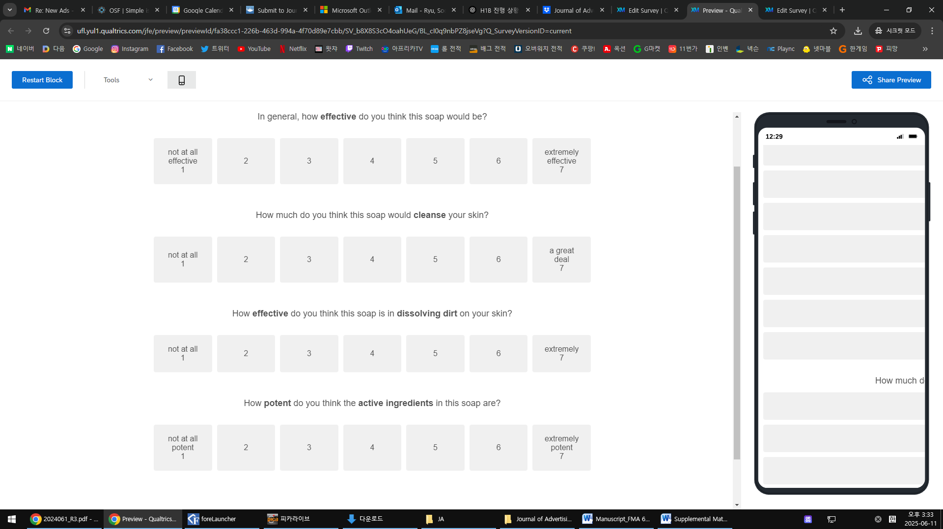




Eco-friendliness perception measure (4 items)
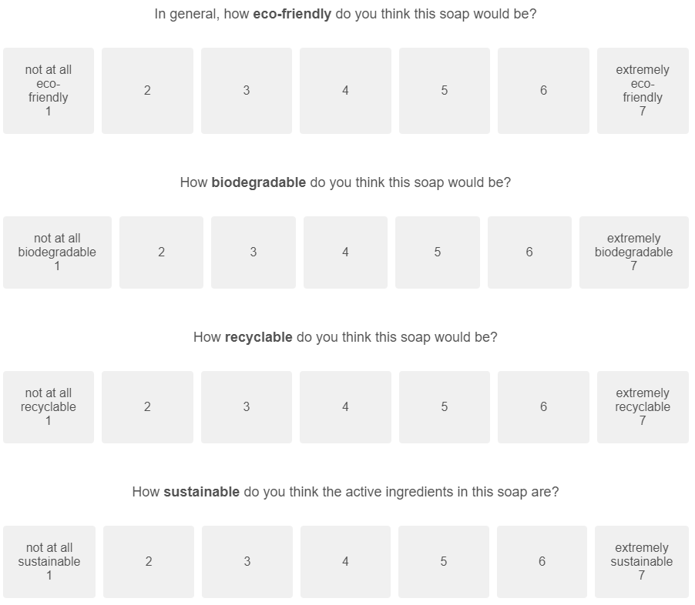


Tangible resources perception measure (4 items)
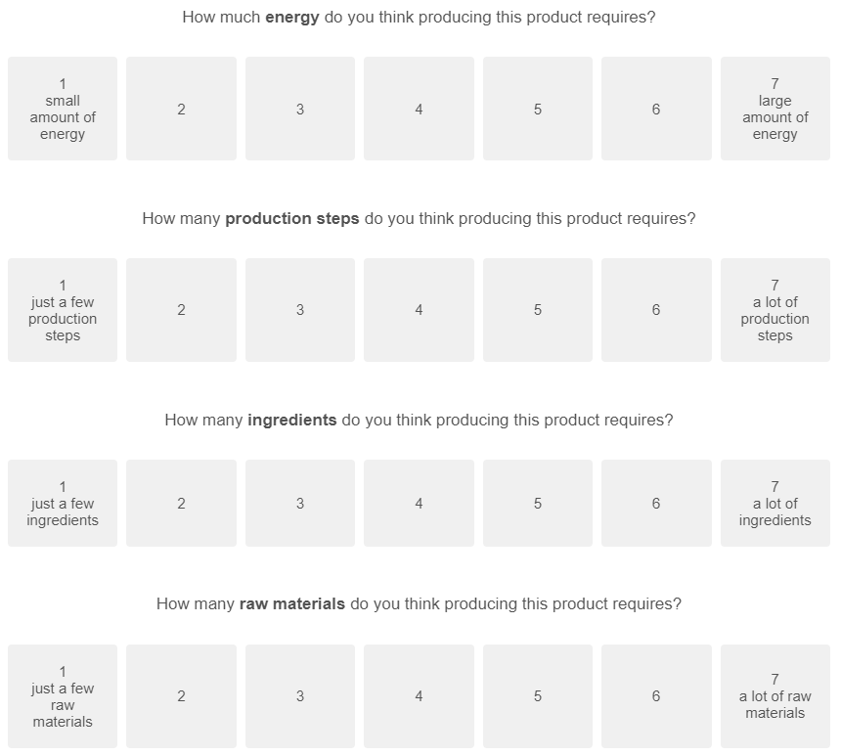



Purchase intention for efficacious product measure (single item)
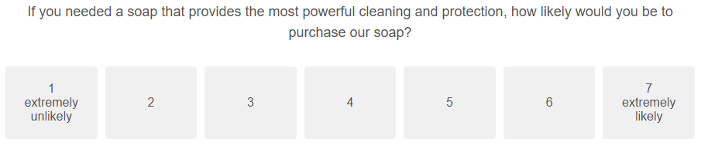

Purchase intention for eco-friendly product measure (single item)
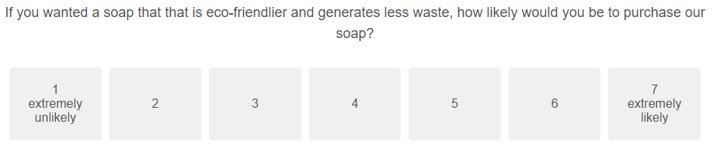

Processing fluency measure (single item)
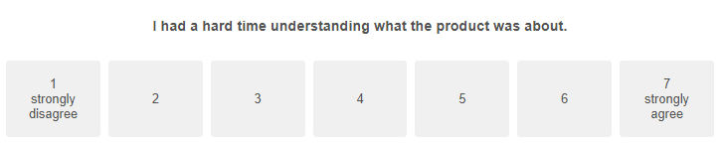

Aesthetic appeal measure (single item)
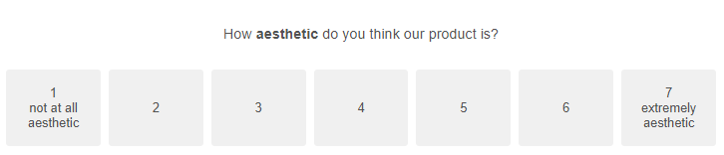

WEB APPENDIX F. CONCEPTUAL REPLICATION OF STUDIES 3A AND 3B AND PERCEPTUAL FLUENCY TEST

Conceptual Replication of Studies 3a and 3b
This study (preregistration: https://aspredicted.org/LWD_77B) provides a conceptual replication of Studies 3a and 3b by testing the effect of visual complexity (vs. simplicity) on perceptions of efficacy and eco-friendliness, and the mediating effect of perceptions of tangible resources used to manufacture the products. Importantly, this study tests several important alternative accounts unaddressed in Studies 3a and 3b.
One may wonder, for example, if visually complex (vs. simple) packaging may be perceived as more efficacious because more elaborate packages look more expensive or luxurious (Jury 2015), which in turn increases perceived efficacy. The opposite is also possible: more minimalistic package design might be perceived as more expensive or luxurious (Pracejus et al. 2006; Sevilla and Townsend 2016), which in turn may increase perceived eco-friendliness. Visually simple (vs. complex) packages might also be perceived as store brands, which can reduce perceptions of efficacy (Bronnenberg et al. 2015).
Finally, we also disentangle the perceived role of tangible vs. intangible production resources. We hypothesized that the effect of package design on perceived efficacy and eco-friendliness is due to tangible production resource perceptions, but one may wonder if perceived intangible resources (e.g., knowledge, skill, effort) also play a role. To tease apart these two constructs, we measured both tangible and intangible manufacturing resource perceptions.

Method

Participants and design We recruited 402 U.S. Prolific participants (45.0% female, M_{age} = 38.75), excluding 49 who did not complete the study and 73 who did not pass the attention check (same as Study 2), in exchange for a small monetary compensation. This study had a 2 (visual package design: complex vs. simple) x 2 (product evaluation focus: efficacy vs. eco-friendliness) between-subjects design. We measured efficacy and eco-friendliness perceptions separately, between-subjects, to avoid any spurious positive or negative correlations or spillover effects.

Procedure We told participants we were developing a new product and were interested in their opinions. Participants read, “Imagine you are shopping for energy drinks. You find an energy drink product named ‘Liquid Electricity’ shown below”. Participants in the complex (simple) visual design condition saw the same complex (simple) energy drink from study 2 (appendix D) and read a descriptive textual cue, “this product has a very complex (simple) look relative to other energy drink products you usually find in stores.” Next, we measured efficacy or eco-friendliness perceptions, based on condition, with a single-item general measure (i.e., how effective (eco-friendly) do you think this product is? 1 = “not very effective [eco-friendly]”, 7 = “very effective [eco-friendly]”, see web appendix D for all measures).
Perceptions of tangible resource use were measured using 4 items: how much energy do you think producing this product requires? (1 = “small amount of energy” to 7 = “large amount of energy”), how many raw materials do you think producing this product requires? (1 = “just a few raw materials” to 7 = “a lot of raw materials”), how many production steps do you think producing this product requires? (1 = “just a few production steps” to 7 = “a lot of production steps”), and how many ingredients do you think producing this product requires? (1 = “just a few ingredients” to 7 = “a lot of ingredients”) (α = .79).
Next, we measured alternative mediators. Perception of intangible resource use was measured using 4 items: how much knowledge do you think producing this product requires? (1 = “little knowledge” to 7 = “a lot of knowledge”), how many skills do you think producing this product requires? (1 = “just a few skills” to 7 = “a lot of skills”), how much effort do you think producing this product requires? (1 = “little effort” to 7 = “a lot of effort”), and how much time do you think producing this product requires? (1 = “a short time” to 7 = “a long time”) (α = .87).
To measure perceptions of price and luxury, we asked: how expensive do you think this product is? (1 = “not very expensive” to 7 = “very expensive”), how prestigious do you think this product is? (1 = “not very prestigious” to 7 = “very prestigious”), and how luxurious do you think this product is? (1 = “not very luxurious” to 7 = “very luxurious”). We also asked: what type of brand do you think the product is from? (1 = “definitely store brand” to 7 = “definitely name brand”). Lastly, we collected demographics and thanked participants.

Results

Product perceptions Supporting our hypothesis and replicating results of Studies 3a and 3b, whereas participants judging product efficacy rated the product with the visually complex package design as more efficacious than the product with the visually simple package design (M_{complex} = 4.93, SD_{complex} = 1.08 vs. M_{simple} = 4.31, SD_{simple} = 1.63; F(1, 398) = 10.85, p = .001; Cohen’s d = .45), those judging eco-friendliness rated the product with the visually simple package design as more eco-friendly than the product with the visually complex package design (M_{complex} = 3.81, SD_{complex} = 1.19 vs. M_{simple} = 4.43, SD_{simple} = 1.34; F(1, 398) = 11.04, p < .001; Cohen’s d = .49). See Figure W1.

Figure W1: Product attribute perceptions based on package design
Simple Visual Design
NOTE. — Error bars = +/− 1 SE. †p < . 10. *p < .05. **p < .01.

Resource usage perceptions We conducted a confirmatory factor analysis (CFA) using two latent factors (tangible and intangible) with their respective items. Standardized factor loadings ranged from .63 to .86, and were all significant (p < .001), suggesting there were no problematic items needing removal (Hair et al. 2006). Further analyses revealed that the model had an acceptable fit (SRMR = .046; CFI = .93), suggesting that the two-factor solution for measuring tangible and intangible resources is a reliable indicator of how people perceive resources used by companies. Finally, we tested for discriminant validity. First, the average variance extracted (AVE) for tangible and intangible resources exceeded their squared correlation (AVE_{tangible} = .499; AVE_{intangible} = .627; squared correlation = .419) (Fornell and Larcker 1981). Second, the 95% confidence interval (CI) around the correlation between the two factors excluded 1 (CI = [.57; .72]) (Bagozzi and Philips 1982). Third, the heterotrait-monotrait ratio of correlations (HTMT) was below the recommended threshold of .90 (.65) (Henseler et al. 2015), suggesting people perceive tangible and intangible resources differently.
A 2 (visual design) × 2 (evaluation focus) ANOVA on perceived tangible resource usage revealed only a main effect of visual design (F(1, 398) = 27.99, p < .001; $η_{p}^{2}$ = .066), with no main effect of evaluation focus (F < 1) or an interaction (F < 1). Regardless of whether they evaluated product efficacy or eco-friendliness, participants perceived the product with the visually complex package design as requiring more tangible resources than the product with the simple package design (M_{complex} = 4.61, SD_{complex} = 1.00 vs. M_{simple} = 4.03, SD_{simple} = 1.18; Cohen’s d = .53).
We conducted a bootstrapping moderated mediation analysis using PROCESS Model 15 (Hayes 2023) with design (complex vs. simple) as the independent variable, tangible resource use as the mediator, product perception (efficacious or eco-friendly) as the dependent variable, and evaluation focus (efficacy vs. eco-friendliness) as the moderator influencing the indirect path between the mediator and DV. The index of moderated mediation was significant (Index = .40; 95% CI: [.20 to .66]), supporting our hypothesis that perceived tangible resource use mediated the effect of package design in opposite directions, as a function of the type of judgment being made. Specifically, when participants judged product efficacy, the indirect effect was positive (a×b = .26, 95% CI: [.13 to .43]), suggesting that visual complexity increased tangible resource usage perception, which in turn increased perceptions of efficacy. When participants judged eco-friendliness, the indirect effect was negative (a×b = -.14, 95% CI: [-.29 to -.02]), such that visual simplicity reduced tangible resource usage perception which in turn increased perceived eco-friendliness.

Alternative explanations A series of 2 (visual design) × 2 (evaluation focus) ANOVAs on intangible resource usage, prestigiousness, expensiveness, and store brand perceptions did not reveal any main effects of visual design (all p’s > .369), evaluation focus (all p’s > .284), or interactions (all p’s > .197). A series of visual design × perception moderated mediation analyses (Hayes 2023; Model 15) suggests that none of these measures mediates the effect of visual design on perceptions of eco-friendliness or efficacy (all 95% CI’s include 0). A 2 (visual design) × 2 (evaluation focus) ANOVA on luxuriousness showed a marginally significant interaction (F(1, 398) = 3.15, p = .077, $η_{p}^{2}$ = .008) with no main effects of design (p = .694) or evaluation focus (p = .698), but luxuriousness did not mediate the effect of design on evaluation (all 95% CI’s include 0).

Discussion

This replication study supports our process by demonstrating that visually complex vs. simple design can influence perceptions of efficacy and eco-friendliness by increasing vs. decreasing perceptions of tangible production resource usage, respectively. In addition, the study rules out additional alternative explanations, including intangible resource use, luxury, prestige, expensiveness, or store brand perceptions.

Ruling Out Perceptual Fluency

One might wonder if our effects occurred because a visually complex design is more perceptually fluent under an efficacy criterion while a visually simple design is more perceptually fluent under an eco-friendliness criterion, resulting in more favorable evaluations. Such an account would not explain the mediation results in Studies 3a and 3b or the moderation by lay theories in Studies 4a and 4b. However, to test this alternative explanation further, we conducted a post-hoc test of perceptual fluency.
Critically, this alternative account would predict a visual complexity x evaluation criterion interaction effect, such that perceptual fluency is higher for the complex (vs. simple) visual design in the efficacy condition, and higher for the simple (vs. complex) design in the eco-friendliness condition. Merely finding a main effect of visual complexity on perceptual fluency would be unsurprising, because more complex designs are — by definition — less perceptually fluent.

Participants and design We randomly assigned 301 Prolific participants to a 2 (visual package design: complex vs. simple) x 2 (evaluation criterion: efficacy vs. eco-friendliness) between-subjects design.

Procedure The procedure was similar to that of Studies 3a and 3b, such that participants evaluated a soap that was either visually complex or simple. To manipulate evaluation criterion, we described the soap as an effective soap that cleanses skin, dissolves dirt, and contains potent active ingredients (efficacy condition; adapted from Study 3a) or an eco-friendly soap that has biodegradable materials, recyclable materials, and contains sustainable active ingredients (eco-friendliness condition; adapted from Study 3b).
Then, we measured perceptual fluency using a standard 5-item scale from prior research (Graf, Mayer, and Landwehr 2018): “the process of understanding the image of the product was…” with (1 = difficult vs. 7 = easy; 1 = unclear vs. 7 = clear; 1 = disfluent vs. 7 = fluent; 1 = effortful vs. 7 = effortless; and 1 = incomprehensible vs. comprehensible; α = .92). If the aforementioned alternative explanation is true, then we should observe an interaction effect such that perceptual fluency is higher for the complex (vs. simple) visual design in the efficacy condition, and higher for the simple (vs. complex) design in the eco-friendliness condition.

Results A 2 (visual design) x 2 (evaluative criterion) ANOVA revealed an expected main effect of visual design, such that the visually complex design (M = 5.36, SD = 1.44) had lower perceptual fluency than the visually simple design (M = 5.96, SD = 1.23; F(1, 297) = 15.08, p < .001). There was also a main effect of evaluation criterion such that perceptual fluency was lower in the eco-friendliness condition (M = 5.47, SD = 1.46) than in the efficacy condition (M = 5.84, SD = 1.25; F(1, 297) = 5.71, p = .017). Critically, there was no interaction between visual design and evaluative criterion (F(1, 297) = .282, p = .596).

Discussion Visually complex (vs. simple) designs are likely to be more difficult to process, by definition. However, the absence of an interaction effect suggests that perceptual fluency is unlikely to be driving the interactive effect of visual complexity and decision criterion. While it is theoretically possible that the greater processing effort associated with certain complex designs could be interpreted favorably under an efficacy criterion and negatively under an eco-friendly one, impacting downstream preference, this explanation is less parsimonious and less plausible given the evidence. It requires individuals to hold two additional lay theories: one equating effort with efficacy and another equating eco-friendliness with ease. Although the first seems reasonable, there is little evidence or theoretical grounding for the second. Moreover, an explanation based on processing ease fails to account for the full body of evidence in this research. Many of our complex designs across studies contain more detail but are not difficult to process (e.g., Studies 1, 2, and 4), so it would be difficult to classify them as disfluent, especially compared with the truly disfluent stimuli typically used in prior work (e.g., hard-to-read fonts). In addition, this account cannot explain the consistent, theory-driven pattern we observed for manufacturing resources as a mediator or for lay theories linking design complexity with manufacturing resources as a moderator. To the extent that design complexity is defined as disfluency, such an explanation becomes tautological.

WEB APPENDIX G. ADDITIONAL DETAILS FOR STUDIES 4A AND 4B

Measures

Eco-friendliness perception measure (4 items)
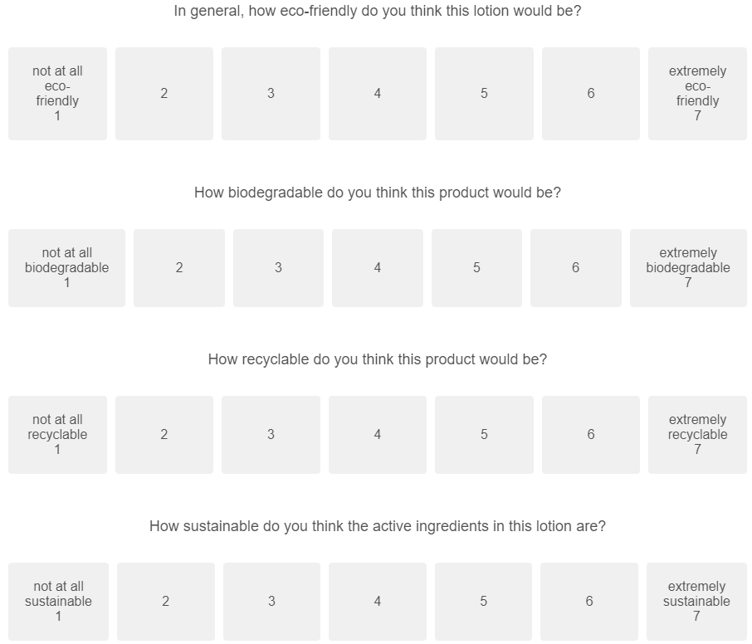




Belief in lay theory measures (8 items)
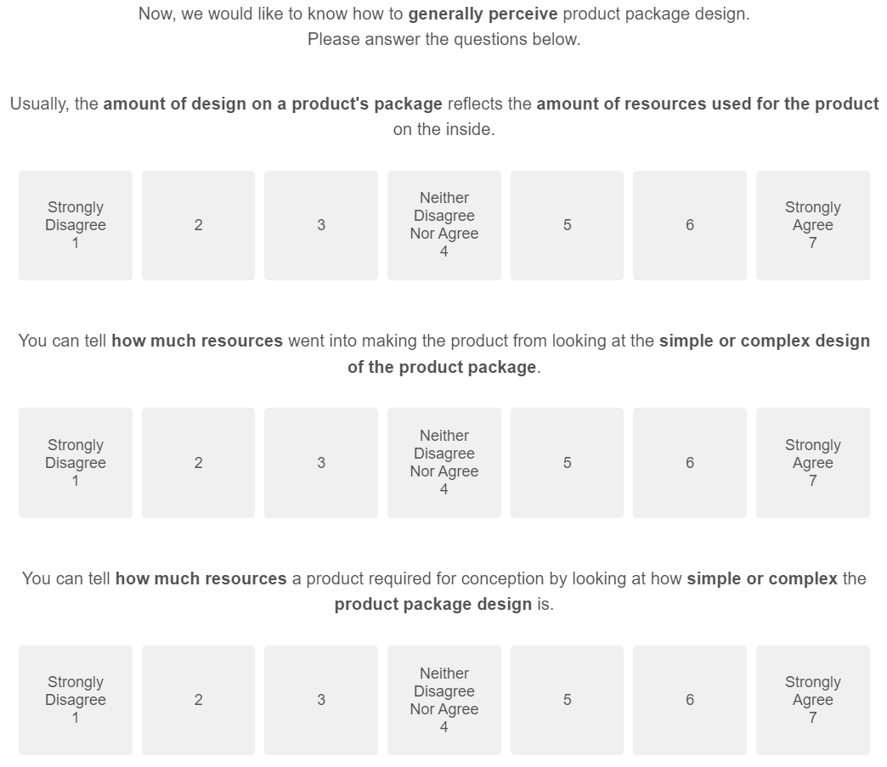


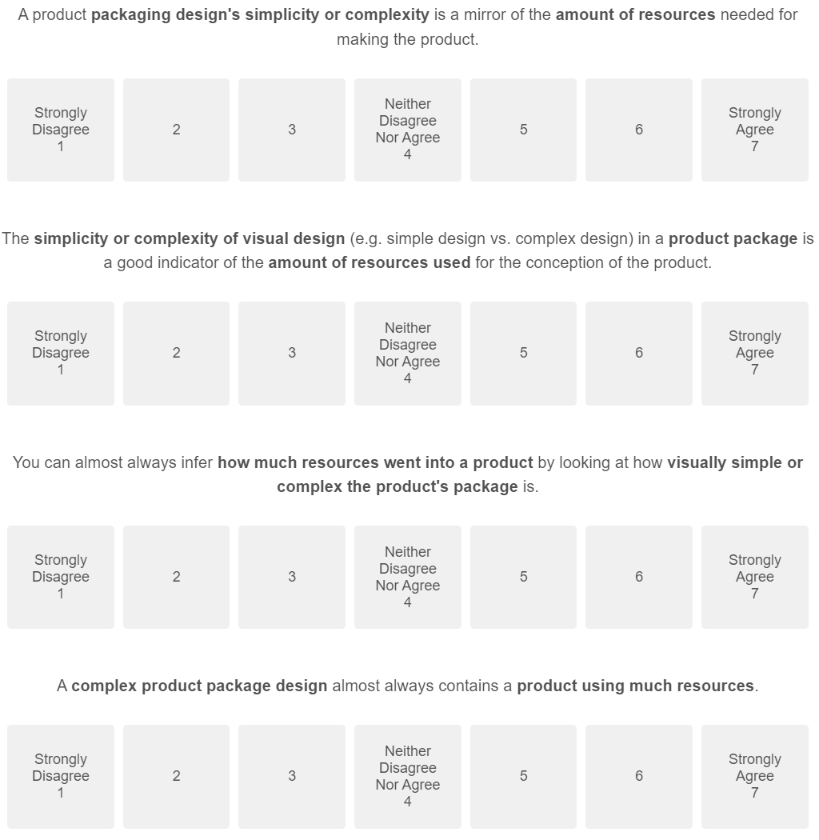
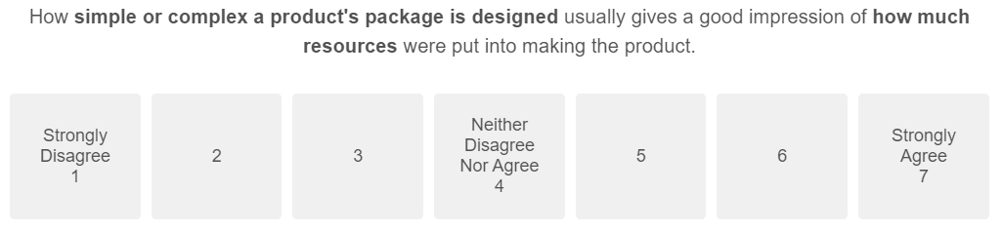

Our manuscript uses six replicates across all studies (energy drink, two versions of soap, protein powder, paper towel, and all-purpose lotion). An additional replicate – all-purpose cleaner – was also pretested, but not used in any of the studies. For transparency, we report the results for all replicates here.

